**Parallel Resonant AC Dielectric Test Sets**

**PAR Series**

The **PAR Series** of Parallel Resonant Test Sets offer the best alternative available for AC high voltage testing high capacitance loads, like large motors & generators, MV cables, large apparatus, iso phase bus, etc. These models are designed to provide a ***Variable Inductance Parallel Resonant*** high voltage source used to test very high capacitance loads. Through tuning the variable inductance of the high voltage reactor to match the capacitive reactance of the load, the apparent power required to test the load is nearly eliminated, greatly reducing the input power required from the test set and from the input lines. Models available from **8 kVac – 250 kVac @ 50 kVA – 300 kVA load** and suitable for 50/60 Hz.

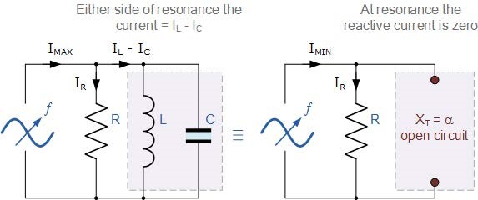

Parallel Resonance Circuit

HVI also produces **many lines of AC Dielectric Test Sets** to serve the multitude of applications needing AC Withstand or Diagnostic testing, like Partial Discharge and Tan Delta.These lines range from small, portable 1 kVA - 3 kVA hipots to field mobile 15 kVA models to 40kVA models for factory use. Some models are < 5pc in PD output and some are CE marked.For more details, refer to the AC Dielectric Test Sets product category or click on the links below

**Alternate AC Voltage Technology Product Line to Consider**

**Very Low Frequency (VLF) AC Test Sets**

The **VLF & VLF E Series** are 0.1 Hz. - 0.01 Hz. AC output hipots for testing very high capacitance loads, like MV/HV power cables and large rotating machinery, that would require hundreds of kVA of test power at 50/60 Hz. Models from **30 kVac - 200 kVac and load rated from 0.1 uF – 50 uF**.

**AC Hipot product lines available from HVI**

**PFT Series:** Portable AC hipots for field use. 10 kVac –100 kVac, 1 kVA –3 kVA

**FPA Series:** Field use apparatus & m/g testers up to 32 kVac @ 15 kVA

**HPA Series:** On-site and stationary use from 3 kVac –300 kVac, 3 kVA –40 kVA

**ABT Series:** Bench type PFT Series models, from 10 kVac – 100 kVac, 1 kVA – 3kVA

**VLF Series:** 0.1 Hz –0.01 Hz. AC for cables and generators. 30 kVac – 200 kVac

**PD/TD Series**: Partial Discharge and Tan Delta accessories also available

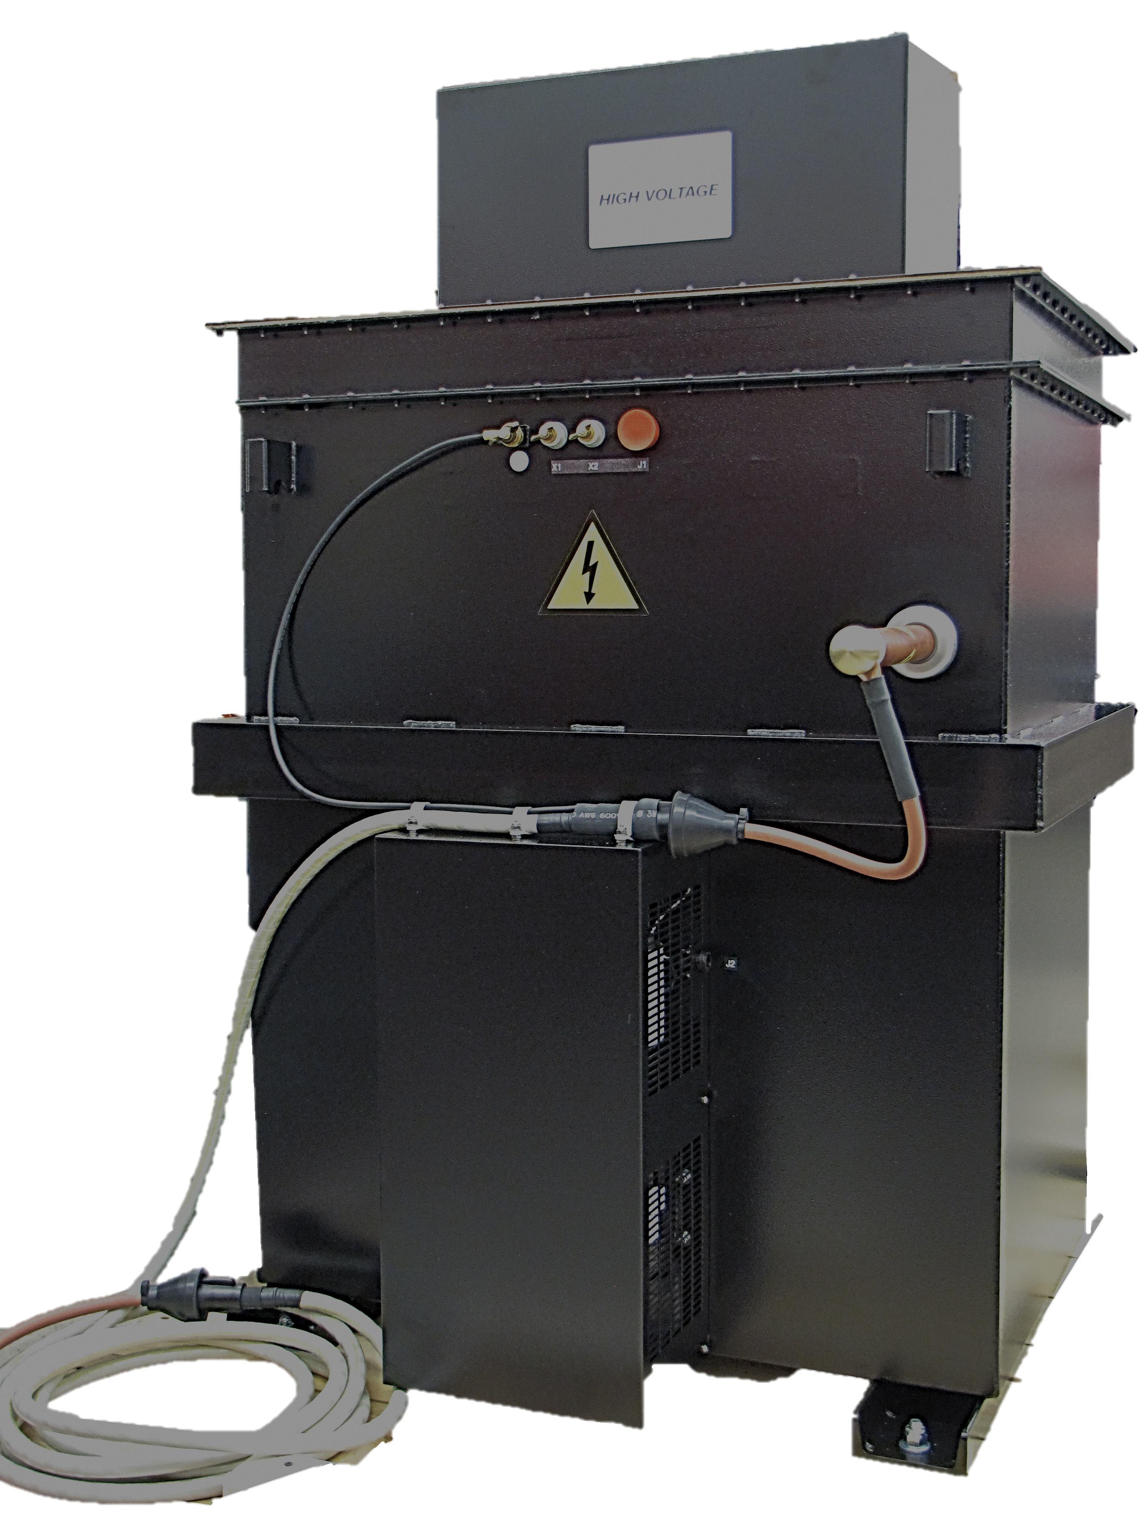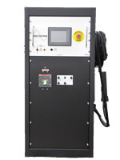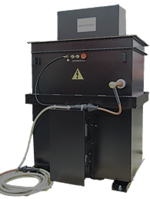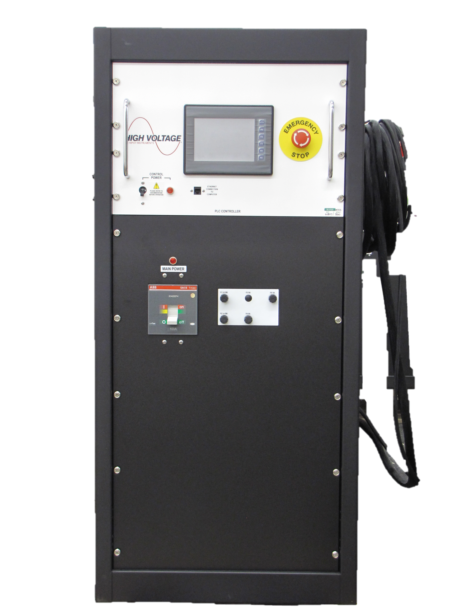

KC Products Section: PAR Series 07/30/19